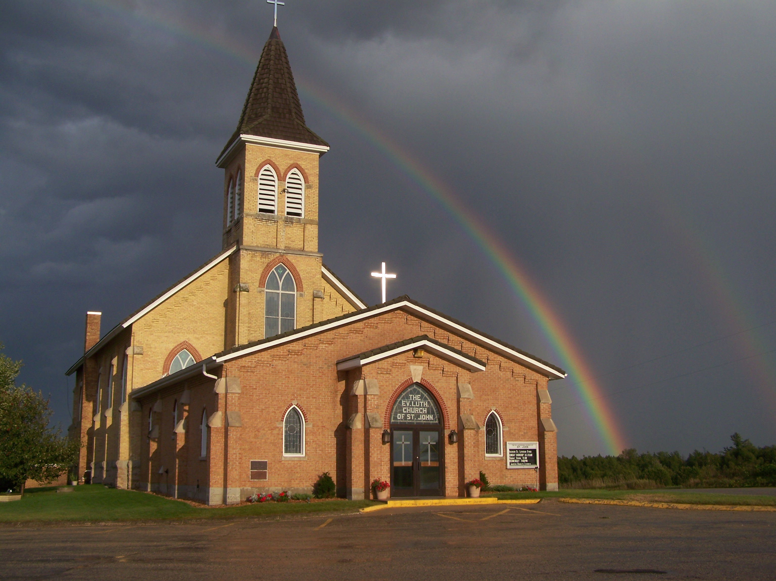
The Evangelical Lutheran Church of St. John
N1916 Church Road
Peshtigo, Wisconsin 54157-9673
Pastor Sargent 920-228-1061

12/31/2020

Dear members of St. John,

Our congregation voted on December 27 to request that our District President permanently assign Mr. Wesley Aguilar as our present Grade 6-8 teacher and that he be mentored as a principal apprentice in the Principal mentor position. We also voted to request that a Grade 3-5 teacher be permanently assigned to us from the December graduates of Martin Luther College.

The Lord has truly blessed us. On December 28, District President Joel Zank communicated to me that Mr. Wesley Aguilar was permanently assigned to us and that Ella Loersch was assigned as our 3-5 Grade teacher. Ella is Wesley Aguilar’s fiancé. Their wedding is set for June of 2021.

Now that the Lord has given us teachers for our school, as a congregation we need to see if we can help with some arrangements during the 6 months period when Ella will be here living on her own. We are looking to see if there is someone within the congregation that is willing to have Ella stay with them. We know that the present pandemic situation makes this request a bit more difficult, but if someone is able to help, please contact Pastor Sargent. (920-228-1061)

Important Information:

Bible Study:

There will be a break in our Bible Study lessons during the Christmas/New Year Holidays. There is a plan to begin a new study on January 10, 2021.

Sunday School:



Attention Parents!

We are in the Winter Lessons. There will be a Christmas and New Year break for Sunday School. The next lesson is set for January 3, 2021. The Lesson will be Gideon’s Victory found in the book of Joshua chapter 7. Please let your Sunday School Teacher or Pastor know if you are having any trouble getting the lessons. We know this is a difficult time because of the pandemic. As of now, we are not able to hold in-person classes. We are very concerned about Sunday School want to make sure parents and children are getting the lessons they need. If you have any questions or concerns you can also call Pastor Sargent (920) 228-1061.

Vacation: Pastor Sargent will be on vacation January 1-3, 2021. If you need the service of a pastor, please contact Pastor Luke Myslik during that time. (507-327-0902)

Worship: If you are not feeling well or have concerns about your own health, you do not need to attend. We will continue with the Livestreaming service at 8:30. If you would like to receive private communion at home please contact Pastor Sargent.

http://www.facebook.com/The-Evangelical-Lutheran-Church-of-St-John-Town-of-Grover-WELS-100389558275581/
https://www.youtube.com/channel/UCJ8tkCadzLHuxGWLhovgl8Q
Pastor Daniel Sargent

